Project Meteor

Game Design Documentation

By Kayne Ruse

<PICTURE>

Table of Contents

Introduction 4

Marketing Information 4

Gallery 5

Storyline 6

Act 1 6

Act 2 6

Act 3 7

Side Quests 8

Mini Games 8

Notes 8

Game World 9

Characters 10

Brock 10

Lucy 10

Theodore 10

Leo 10

Locations 11

Jordania 11

Tomb City 11

Dungeons 12

Ruins 12

Wastelands 12

Forest 13

Mountain 13

River Valley 13

Tomb City 13

Lost Desert 13

Tower of Babel 13

Monsters 14

Rodents 14

Slime 14

Game Mechanics 15

Player Controls 16

Game Objects 17

Game World Generation 18

Character Levels, skills and abilities 19

Tutorials 20

Gameplay 20

Combat 20

Game Assets 21

Graphical Assets 21

Audio Assets 21

Screen Flow 22

Technical Details 23

Formulas and Equations 24

Character and Equipment Statistics 24

Combat Damage Equation 24

Level Experience Equation 24

Development Schedule 25

Preproduction 25

Prototyping 25

Alpha Stage 25

Beta Stage 25

Release 1.0 25

Back Burner 25

Cancelled Content 26

To Do List 26

Post Mortem 27

Development Notes 28

References 29

Credits 30

# Introduction

Meteor <working title> is a top down dungeon crawler role playing game (RPG) where you take on the role of Brock, a boy who must find and save his little sister <working story>.

The game is viewed in a three dimensional world from a fixed camera position, with pixel sprites used for characters, objects and enemies in the game world. A majority of the game world consists of randomly generated dungeons with multiple “floors”. Each floor is built from a set of prefabricated meshes placed in a grid based pattern, depending on the dungeon’s theme.

The player must fight enemy monsters, mini bosses and dungeon bosses as they travel through each dungeon. The mini and dungeon bosses are scattered throughout the levels, as specified by the dungeon generators.

The game world also has a hub location, a town called Jordania, which acts as a staging area for the player. A short tutorial is presented to the player at the beginning off the game, with a much more complete version available from the game’s hub.

# Marketing Information

Meteor <working title> is an open source, free dungeon crawler role playing computer video game developed by KR Studios and produced by Sideways Eight Productions. The game’s development process will be publicly documented as the game progresses, with user feedback going towards and guiding the development of the game. The primary information and distribution channels for the game are the KR Studios development blog, Sideways Eight Productions website and the GitHub.com git repository page.

# Gallery

<Screenshots>

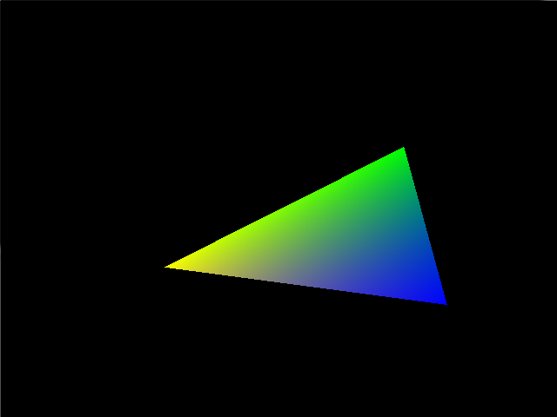

# Storyline

<FLOWCHART>



Act 1 is a basic setup, but also acts as a tutorial for the users with signposts detailing control systems, how to fight, etc. It also provides the premise for the adventure: rescue your sister. Act 2 will be the main part of the game, where the player can explore, learn and eventually roam free around the world, achieving each of the main story goals, and any of the side quest goals available. Act 3 will be available when the player has completed the main story goals. This will be the long goal of the game, but will be overall short but detailed, and will wrap up the game’s storylines. There is a split ending as noted below.

### Act 1

Brock is a 12 year old boy who has a 10 year old little sister called Lucy. The two kids were playing near some old ruins one day, when suddenly, a monster appeared and kidnapped Lucy, taking her into the ruins. Since the two kids are alone besides each other, it is up to Brock to save her.

After defeating the enemies inside the ruins, Brock falls into a magic portal that transports him to another world.

### Act 2

In the new world called Ivalice <working name>, Brock finds a town called Jordania <working name>, which acts as a hub for the greater part of the game. Here, the player can wander around, buy things at the markets, talk to NPCs for advice, and overall prepare for exploring the world.

After talking to a number of the NPCs in the town, the player learns that the monster that kidnapped his sister lives in the distant northern wastes <working concept>. One NPC, called Theodore <significant character, elderly, working name> approaches Brock to warn him about adventuring alone, and advises that he explore a dungeon to the south, which holds an item that will help him greatly on his quest.

After defeating said dungeon, Brock receives a power stone. This ups his attack power, and allows him to use magic. Using this magic, Brock gets deeper into the northern dungeon, but after confronting the final boss Leo, who he assumes kidnapped his sister, he is defeated and wakes up again in the town.

Brock is told by Theodore that other dungeons contain more power stones that can boost his strength. With this new information, Brock sets out to gather the stones and become stronger to save his sister. The player then progresses to each of the other dungeons in the world.

At this point, the player has free reign on most of the world, and can defeat each dungeon in any order he wants. However, some dungeons may be inaccessible without elements from elsewhere in the game. Also, there are bonus areas that cannot be unlocked without the abilities gained from another dungeon.

### Act 3

When the player has defeated the basic necessary parts of the dungeons, the final dungeon will become available. Defeated similarly to the other dungeons, when the Brock reaches the final boss, he will confront Leo, and defeat him.

During the first stage of the fight, the player will fight Leo normally. When the player defeats Leo, Theodore appears, and attacks Leo. Failing the attack, it is revealed that both Leo and Theodore are immortal, and their immortality is linked.

Since all of the stones have been gathered by Brock, Leo absorbs Theodore’s power and immortality killing him and becoming even stronger, this being his apparent goal. This begins the second stage of the fight, and the player must defeat Leo in this super state.

When the second stage of the fight is complete (Leo does not die yet, but is severely weakened), Brock demands to know why his sister was taken, but Leo scoffs and states:

“That little girl was just a snack for a monster. If I hadn’t come across her in the wastes she’d be dead.”

With this revelation, Brock demands to see her, and Leo complies. Questioning if Theodore was just manipulating Brock for his own attempt to gain power, the player has a choice. Either run away with his sister, and let Leo live, or finish the fight and avenge Theodore’s death. This choice is intended to have the player ponder the final outcome of the game.

If the player decides to flee, the game ends, with Theodore shown commenting that he thought He could defeat Leo with the stones, but ultimately failed like an old fool. He is shown to be very bitter.

If the player decides to defeat Leo, the game ends, and shows Leo commenting that his old friend chose a great puppet. He also thanks Brock for ending their centuries old feud. He is shown to be content with the result of the game.

## Side Quests

A side quest is a task within a video game that does not contribute to the main storyline, but can often provide bonuses that can assist the player in the main storyline’s quests. Side quests often allow the player to explore more of the game world, provide some back story for the game’s setting, and offer a distraction to the player when they become bored of the main storyline for a short time.

The game will have multiple side quests available.

<Text>

## Mini Games

A mini game is a “game within a game”, often providing short term bonuses for successful play throughs, as well as short, optional distractions to the player. The gameplay of a mini game is usually simplistic in nature, often akin to an arcade game.

The game will have multiple mini games available.

<Text: Card game, mechanics like triple triad?>

<Text>

## Notes

The split ending is intended to make the players think about the ending, and even have different views from other people who chose a different ending.

The only points in the above outline where the sister is mentioned are in the beginning and the end. This might make people simply not care about the sister, therefore special care must be taken when the storyline is fleshed out.

The side quests and mini games will be time consuming to the main development cycle, however these can be outsourced.

# Game World

Most if this game is set in the world of Ivalice <change/remove this name>, while the tutorial takes place in Brock’s unnamed home world. The town of Jordania acts as a staging area for the player, and a hub for the game. Other towns do exist, but don’t play a major role <check during revision>. Dungeons are scattered around the world and are accessed by travelling through fields. Some areas, like the dungeons listed below, are randomly generated according to certain criteria, while others like the town and the fields are loaded from files.

## Characters

### Brock

Brock is the 12 year old protagonist of the story. He has some formal training in swordplay, but has never seen actual combat. He has raised Lucy almost on his own for the last two years, and is very protective of her. Despite believing that he is mature and brave, he still has a lot to learn.

### Lucy

Lucy, Brock’s 10 year old sister, looks up to her brother as a hero. Small for her age, she is never far behind brock on their travels.

### Theodore

Theodore I a wise old man who lives in Jordania; he has exceptional sword skills, but has grown weak in his old age.

### Leo

Leo is the antagonist of the story. A powerful old mage, he draws his magic from meteor stones that fell from the sky when he was a child. He has hidden these meteor fragments in the most dangerous places in the world, so that nobody else can take away his power.

## Locations

### Jordania

Jordania is a town on a river, home of Theodore. Brock finds his way here after being teleported to this world.

### Tomb City

Previously known by another name, the city gates were closed many years ago after a plague broke out. Now the city stands, uninhabited, as a tomb to its occupants. The city gates remain shut to this day.

## Dungeons

There are 8 dungeons in the game, each with unique theme and setting. As each dungeon is completed, the player gains new abilities and access to new areas <check during revision>. Each dungeon is made up of a series of floors, with each floor randomly generated as the player begins. The floors are designed using a set of parameters, such as size, chest count, and difficulty. Dungeon specific exceptions to these rules do exist, as noted below.

### Ruins

The ruins are located in Brock’s home world, and act as a tutorial to the player. This dungeon is easy, with relatively few monsters and low level item chests. There are three levels, the first two being regular, while the last is an area when the character faces of against the monster that kidnapped his sister, and also holds the portal to Ivalice. After the tutorial is completed, the player cannot return to this dungeon.

This dungeon is not randomly generated like the others, allowing a more focused path through the beginning of the game. The walls and ground are made of stone, with a few torches scattered around to provide (aesthetic) light.

### Wastelands

The wastelands are a unique dungeon in several aspects. First, it has only one level with no fixed size or difficulty, and as the player moves around inside it the dungeon reshapes itself, making backtracking impossible. The only ways to exit the wastelands is to select the “run” option from the pause menu.

When the player enters this dungeon a counter begins to keep track of the number of unique dungeon segments that the player passes through, only presenting the goal to the player after a certain number of segments have been traversed.

The player can enter the wastelands as a sort of “bonus” dungeon, as a distraction from the main storyline. This can provide items that might be too hard or too high level to obtain elsewhere.

<The game balance needs some serious thought, since this is so crucial>

The game balance in the wastelands in intentionally bizarre, since a low level player can face off against a high level monster, a high level monster can drop low level items, and the overall balance is against the player. Although high level monsters of any kind can be found here, the player cannot find high level items within chests without first being far enough through the game as to need it <check during revision>.

This is the second dungeon that the player can enter, despite the high level rating. It is, story wise, crucial as the place the player faces off against Leo for the first time. Therefore, this dungeon has the ability to scale the upper and lower difficulties. It also provides access to the final dungeon when the player is far enough through the game.

There are buildings that can be occasionally found, like tombs or shacks that can be entered. There are also humans that have been lost in here, who can either fight the player, or be guided out by them.

The wastelands are presented as badlands with large rocks, riverbeds and a vivid reddish colour scheme.

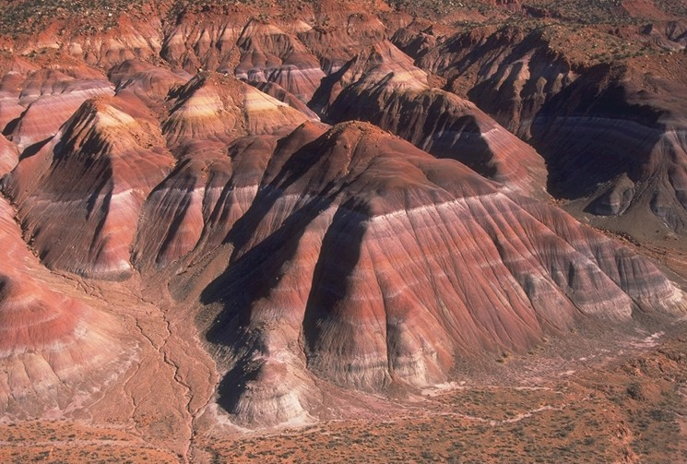

### Forest

<Text>

### Mountain

<Text>

### River Valley

<Text>

### Tomb City

<Text>

### Lost Desert

<Text>

### Tower of Babel

<Text>

## Monsters

<Text>

### Rodents

<Text>

### Slime

<Text>

# Game Mechanics

<Text>

### Player Controls

<Text>

Keyboard and Mouse

<Text>

Gamepad

<Text>

### Game Objects

<Text>

### Game World Generation

<Text>

### Character Levels, skills and abilities

<Text>

# Tutorials

<Text>

### Gameplay

This tutorial takes place in the ruins at the start of the game.

<Text>

### Combat

This tutorial is quickly rushed in the ruins, but a more complete version is available from Theodore.

<Text>

# Game Assets

<Text>

### Graphical Assets

<Text>

### Audio Assets

<Text>

# Screen Flow

<Diagram>

# Technical Details

<Text>

# Formulas and Equations

### Character and Equipment Statistics

Level

Current HP, Max HP

Current MP, Max MP

Melee Attack, Melee Defence

Magic Attack, Magic Defence

Weapon, Armour

### Combat Damage Equation

dam = max( C.Atk + C.Wpn – E.Def, 1)

E.CHP = E.CHP – max(dam – floor(E.Amr/2), 0)

|  |  |
| --- | --- |
| Key | Value |
| C | This Character |
| E | Enemy Character |
| Dam | Damage Value |
| CHP | Current Health Points |
| Atk | Attack Points |
| Def | Defence Points |
| Wpn | Weapon Points |
| Amr | Armour points |

### Level Experience Equation

<TEST THESE: I need a spread sheet of this>

E = A(BC)

|  |  |
| --- | --- |
| Key | Value |
| E | Experience needed for this level |
| A | Experience needed for level one |
| B | Ratio modifier expressed as a decimal |
| C | Current level |

# Development Schedule

This game has no defined deadline or release date. However the development cycle must be kept in check to ensure that the game does not become vapourware. The Game Design Document must be kept up to date with any policy or development cycle changes.

### Preproduction

Distribution channel established

Creation of Game Concept Document

Production and development teams formed

### Prototyping

OpenGL Prototype

Dungeon Generation Prototype

Gameplay Prototype

Statistics Prototype (mixed with Dungeon Generator prototype?)

Concept Art

Concept music/sounds

<Text>

### Alpha Stage

Movement

Combat

Placeholder assets

Placeholder plotline

Plotline implementation (dialog, scripts, etc)

<Text>

### Beta Stage

<Text>

### Release 1.0

<Text>

### Back Burner

A card game mini game reminiscent of Final Fantasy VIII Triple Triad

<Text>

## Cancelled Content

A major component of the original concept what a “Magic: the Gathering” like mechanic acting as a large portion of the game. This has been rejected; however a simple card game mini game will be reintroduced later in the development cycle.

<Text>

## To Do List

Complete the OpenGL prototype.

Complete The Dungeon Generation prototype.

Flesh out the different sections of this document.

<Text>

# Post Mortem

<Text>

# Development Notes

<Text>

These snippets must be moved to another location in the GDD.

• Magic is ranged, but consumes MP.

• Magic cannot be used until the end of dungeon 3.

• If there is a “monster compendium” in the game, the data of the monster is not available until that monster is “scanned.”

• Each floor has X chests on it.

• pause menu

I need:

A writer

A concept artist

An artist (further down the road)

# References

<https://github.com/Ratstail91/Project-Meteor>

<http://kr-studios.tumblr.com/>

<http://sidewayseight.webs.com/>

<remove these later>

<http://finalfantasy.wikia.com/wiki/Triple_Triad>

<http://tvtropes.org/pmwiki/pmwiki.php/Main/SpritePolygonMix>

<http://tvtropes.org/pmwiki/pmwiki.php/Main/NewGamePlus>

<http://tvtropes.org/pmwiki/pmwiki.php/Main/MonsterCompendium>

<http://en.wikipedia.org/wiki/File:Chinle_Badlands.jpg>

# Credits

<

Each person can have their say as to how they are credited

Each of these sections needs to be filled

The credit can either got to individuals, or the companies

The italics shows areas that can be replaced

>

|  |  |
| --- | --- |
| Project Lead | Kayne Ruse |
| Lead Producer |  |
| Project Production | Sideways Eight Productions |
| Lead Writer | *Kayne Ruse* |
| Storyline | *Kayne Ruse* |
| Character Design | Kayne Ruse |
| Lead Artist |  |
| Game Art |  |
| Concept Art | Kayne Ruse |
| Lead Composer |  |
| Music |  |
| Sound |  |
| Lead Developer | Kayne Ruse |
| Project Development | KR Studios |
| Level Design |  |
| Initial Concept | Kayne Ruse |
| Game Design Documentation | Kayne Ruse |
| 2012 KR Studios, Sideways Eight Productions | |
|  | http://d2bm3ljpacyxu8.cloudfront.net/width/280/crop/0,0,280x186/sidewayseight.webs.com/Sideways%20Eight.jpg |